|  |
| --- |
| Experiment No.2 |
| Apply Tokenization on given English and Indian Language  Text |
| Date of Performance: |
| Date of Submission: |

Aim: Apply Tokenization on given English and Indian Language Text

Objective: Able to perform sentence and word tokenization for the given input text for English and Indian Langauge.

Theory:

Tokenization is one of the first step in any NLP pipeline. Tokenization is nothing but splitting the raw text into small chunks of words or sentences, called tokens. If the text is split into words, then its called as 'Word Tokenization' and if it's split into sentences then its called as 'Sentence Tokenization'. Generally 'space' is used to perform the word tokenization and characters like 'periods, exclamation point and newline char are used for Sentence Tokenization. We have to choose the appropriate method as per the task in hand. While performing the tokenization few characters like spaces, punctuations are ignored and will not be the part of final list of tokens.

Why Tokenization is Required?

Every sentence gets its meaning by the words present in it. So by analyzing the words present in the text we can easily interpret the meaning of the text. Once we have a list of words we can also use statistical tools and methods to get more insights into the text. For example, we can use word count and word frequency to find out important of word in that sentence or document.

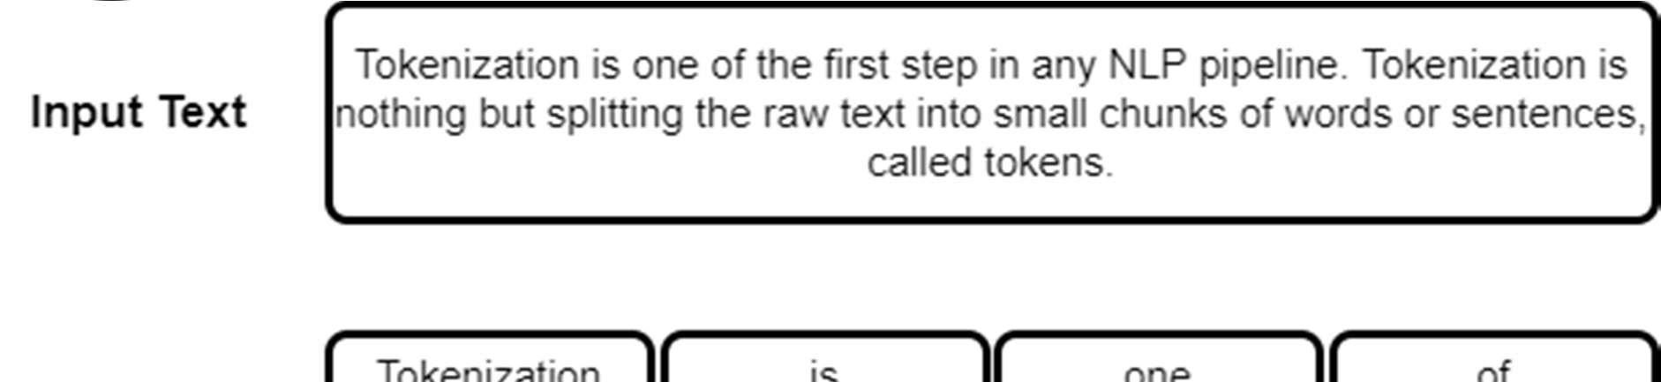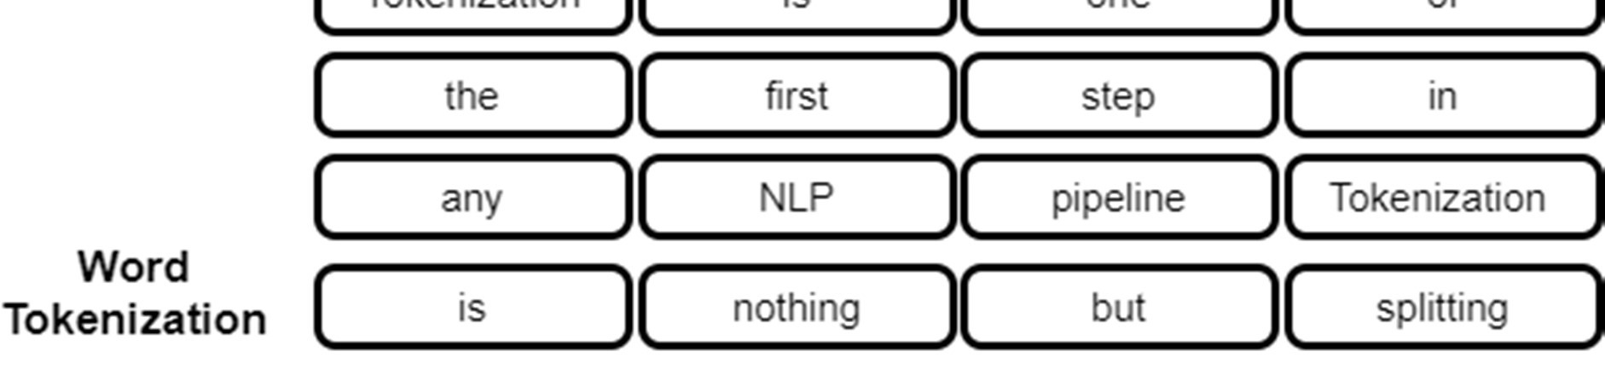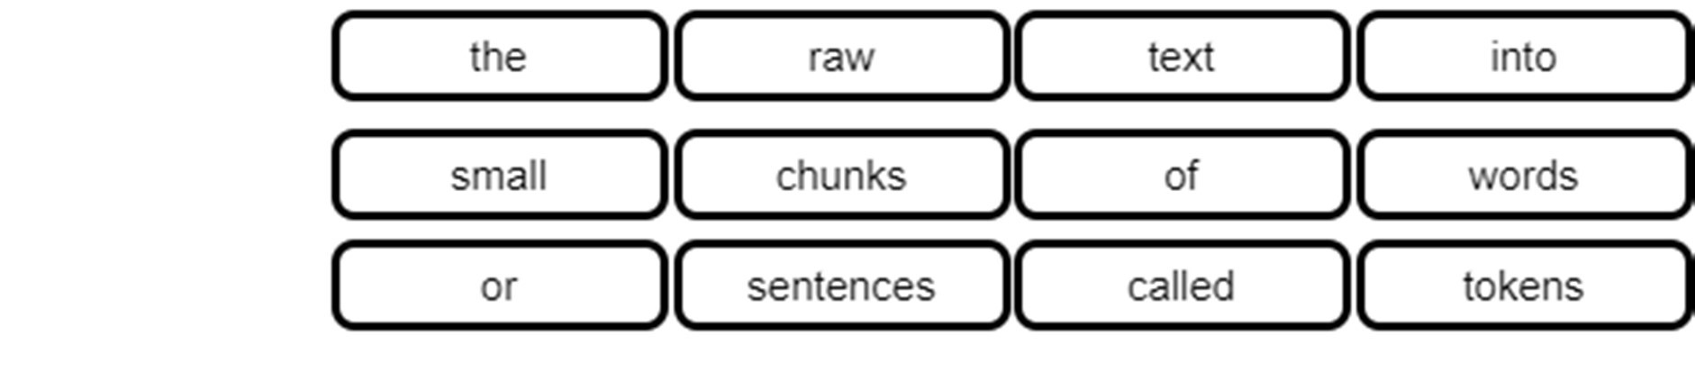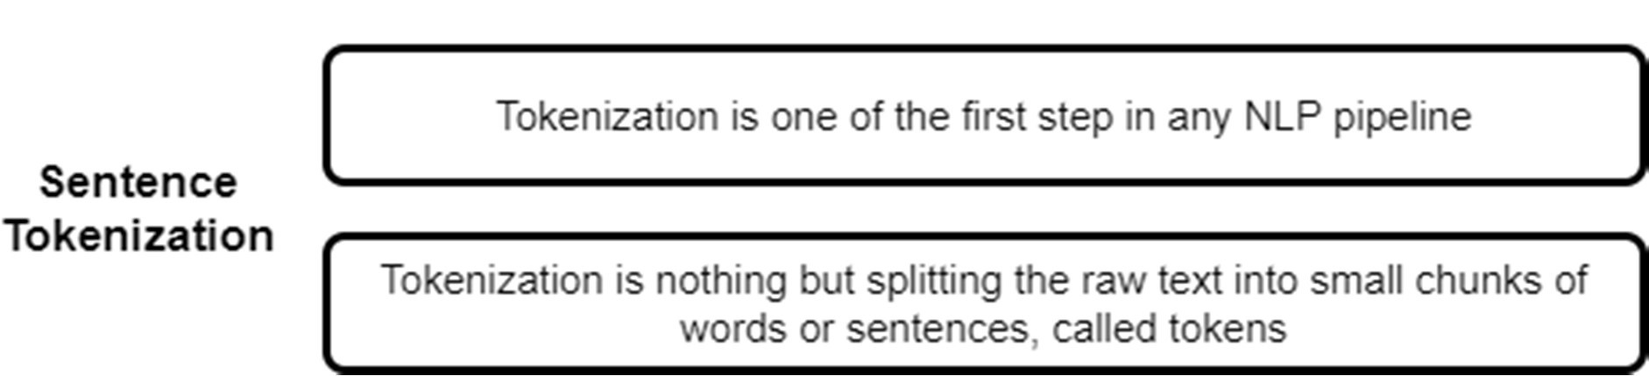

# Library required for Preprocessing

!pip install nltk

Requirement already satisfied: nltk in /usr/local/lib/python3.10/dist-packages (3.8.1)

Requirement already satisfied: click in /usr/local/lib/python3.10/dist-packages (from nltk) (8.1.6)

Requirement already satisfied: joblib in /usr/local/lib/python3.10/dist-packages (from nltk) (1.3.2)

Requirement already satisfied: regex>=2021.8.3 in /usr/local/lib/python3.10/dist-packages (from nltk) (2023.6.3)

Requirement already satisfied: tqdm in /usr/local/lib/python3.10/dist-packages (from nltk) (4.66.1)

import nltk

nltk.download() ** NLTK Downloader

---------------------------------------------------------------------------

d) Download l) List u) Update c) Config h) Help q) Quit

---------------------------------------------------------------------------

Downloader> d

Download which package (l=list; x=cancel)?

Identifier> punkt Downloading package punkt to /root/nltk_data...

Unzipping tokenizers/punkt.zip.

---------------------------------------------------------------------------

d) Download l) List u) Update c) Config h) Help q) Quit

---------------------------------------------------------------------------

Downloader> q

True

# Sentence Tokenization

from nltk.tokenize import sent_tokenize

text = '''In probability, two events are independent if the incidence of one event does not affect the probability of the other event. If

text

'In probability, two events are independent if the incidence of one event does not affect the probability of the other event. If the dent.'

sentences = sent_tokenize (text)

sentences

['In probability, two events are independent if the incidence of one event does not affect the probability of the other event.',

'If the incidence of one event does affect the probability of the other event, then the events are dependent.'] Word Tokenization

from nltk.tokenize import word_tokenize

words = word_tokenize (text)

words

['In',

'probability',

',',

'two',

'events',

'are',

'independent',

'if',

'the',

'incidence',

'of',

'one',

'event',

'does',

'not',

'affect',

'the',

'probability',

'of',

'the',

'other',

'event',

'.',

'If',

'the',

'incidence',

'of',

'one',

'event',

'does',

'affect',

'the',

'probability',

'of',

'the',

'other',

'event',

',',

'then',

'the',

'events',

'are',

'dependent', '.']

for w in words:

print (w)

In

probability

, two events are independent if the incidence of one event does not affect the probability of the other event

.

If the incidence of one event does affect the probability of the other event

, then the events are dependent .

# Levels of Sentences Tokenization using Comprehension

sent_tokenize (text)

['In probability, two events are independent if the incidence of one event does not affect the probability of the other event.',

'If the incidence of one event does affect the probability of the other event, then the events are dependent.']

[word_tokenize (text) for t in sent_tokenize(text)]

[['In',

'probability',

',',

'two',

'events',

'are',

'independent',

'if',

'the',

'incidence',

'of',

'one',

'event',

'does',

'not',

'affect',

'the',

'probability',

'of',

'the',

'other',

'event',

'.',

'If',

'the',

'incidence',

'of',

'one',

'event',

'does',

'affect',

'the',

'probability',

'of',

'the',

'other',

'event',

',',

'then',

'the',

'events',

'are',

'dependent',

'.'], ['In',

'probability',

',',

'two',

'events',

'are',

'independent',

'if',

'the',

'incidence',

'of',

'one',

'event', 'does',

from nltk.tokenize import wordpunct_tokenize

wordpunct_tokenize (text)

['In',

'probability',

',',

'two',

'events',

'are',

'independent',

'if',

'the',

'incidence',

'of',

'one',

'event',

'does',

'not',

'affect',

'the',

'probability',

'of',

'the',

'other',

'event',

'.',

'If',

'the',

'incidence',

'of',

'one',

'event',

'does',

'affect',

'the',

'probability',

'of',

'the',

'other',

'event',

',',

'then',

'the',

'events',

'are',

'dependent',

'.']

# Filteration of Text by converting into lower case

text.lower()

'in probability, two events are independent if the incidence of one event does not affect the probability of the other event. if the dent.'

text.upper()

'IN PROBABILITY, TWO EVENTS ARE INDEPENDENT IF THE INCIDENCE OF ONE EVENT DOES NOT AFFECT THE PROBABILITY OF THE OTHER EVENT. IF THE DENT.'



Conclusion:

Tokenization is a fundamental natural language processing (NLP) task that involves breaking a text into smaller units called tokens. These tokens can be words, subwords, or characters, depending on the level of granularity chosen for analysis. To perform tokenization on both English and an Indian language text, we need to consider the specific characteristics of each language.

CSDL7013: Natural Language Processing Lab